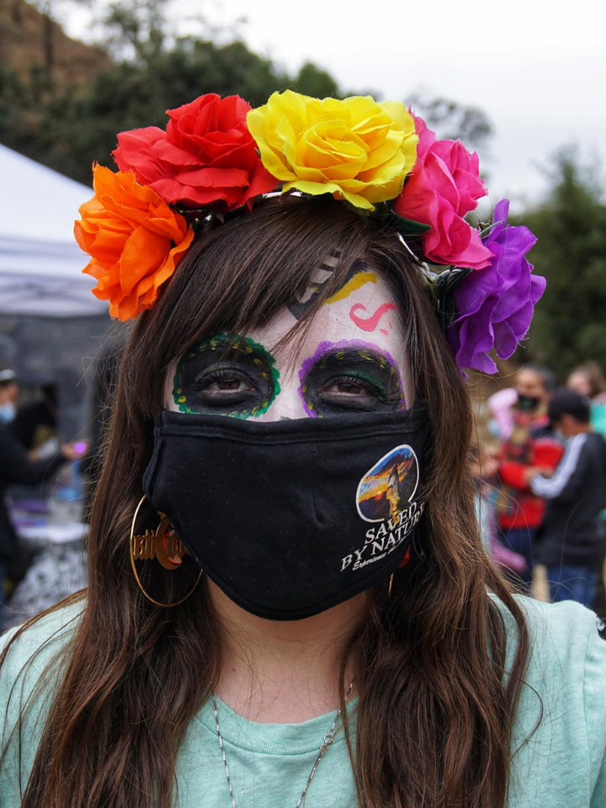
Sponsorship Proposal 2022
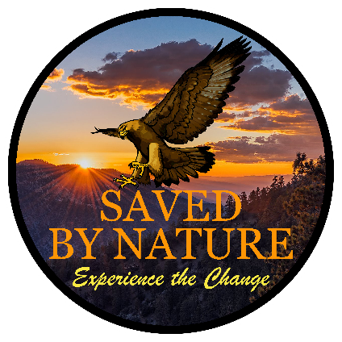

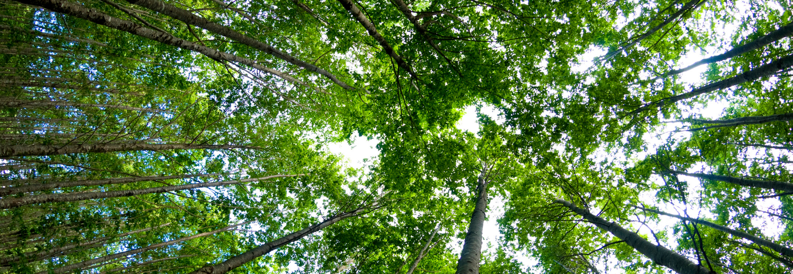
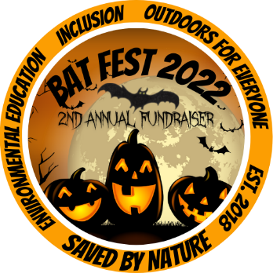
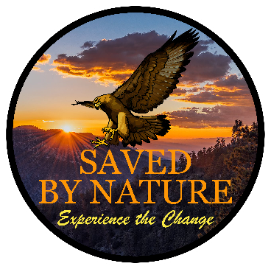

FALL 2022 SPONSORSHIP PACKET

Be an advocate of environmental and social justice!

Saved By Nature is pleased to announce Bat Fest 2022 – our largest community event of the year!
We invite you to be part Saved By Nature’s community by sponsoring our 2nd annual fundraising event this October 22nd, 2022! Your support will help a blossoming nonprofit continue to champion environmental and social justice. Sponsorship provides a fun filled experience for members of your organization as well as for South Bay families with less resources! This year we’ll return to Rancho Canada del Oro Open Space Preserve and offer activities such as festival games, an outdoor movie, food truck, live bats and more! We hope you will join us in creating an inclusive natural space where everyone of all ethnicities feels a sense of belonging. Please see our event flier for more details about how to become part of our Community Bat Fest.

Since April of 2019 we have directly impacted 6,929+ members from our community through public hikes, virtual nature hikes, seniors hiking for health and youth education.

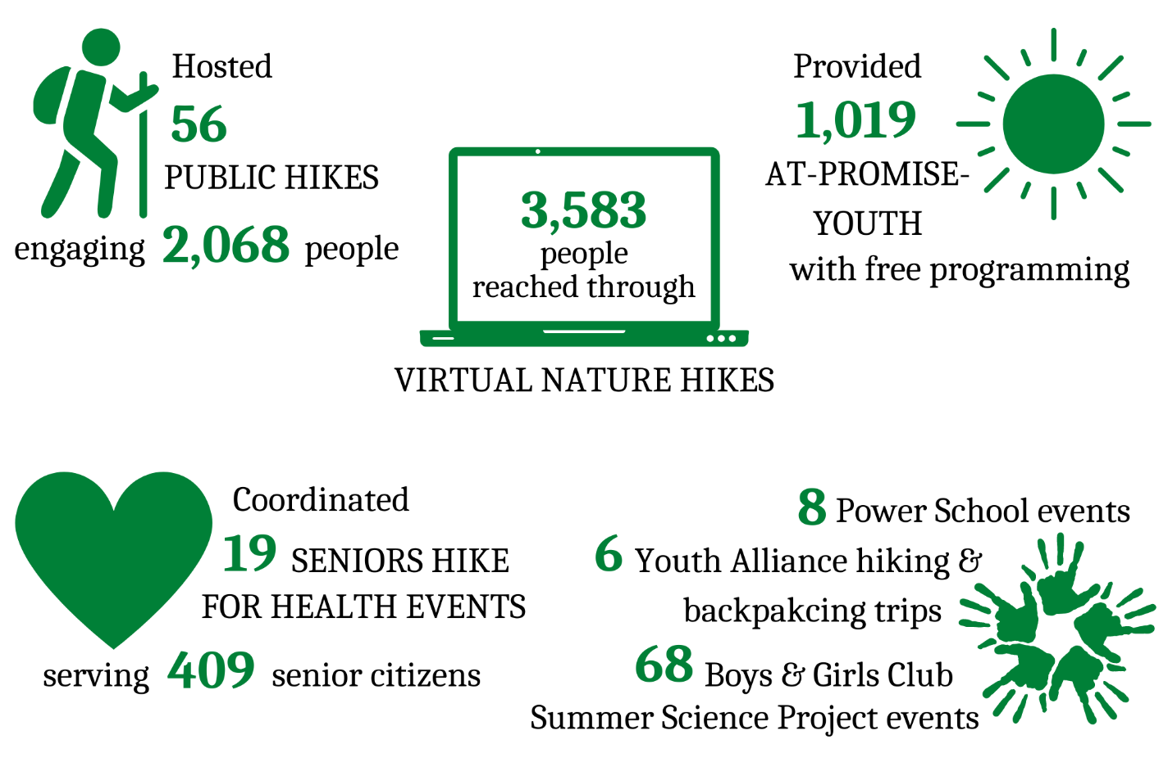

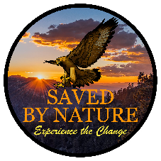
2022 SPONSORSHIP OPPORTUNITIES

By sponsoring, you let our community and supporters know that you value social justice, equity, inclusion, and environmental education. All sponsors will be featured on our website, acknowledged in emails, and included in event materials unless requested otherwise.

Environmental &
California Badger
SUPPORTER
Steelhead Trout
Social Justice ALLY
Education HERO
Environmental

Diversity & Inclusion
CHAMPION
Parks & Open Space

Tule Elk

SPONSORSHIP LEVELS | $150  Burrowing Owl  FRIEND | $250  PROTECTOR | $500 | $750  DEFENDER | $1,000  ADVOCATE | $5,000 | $10,000 | $25,000
Event tickets | 2 | 2 | 4 | 6 | 6 | 10 | 10 | 10
Raffle tickets | 2 | 2 | 4 | 6 | 6 | 10 | 10 | 10
Event activity tickets | 4 | 4 | 8 | 12 | 12 | 20 | 20 | 20
Event tickets gifted to a family who would not be able to attend otherwise | 1 family | 2 families | 3 families | 4 families | 5 families | 6 families | 7 families | 8 families
Logo & link advertised at the festival snack booth and photo with animal |  | ✓
Logo & link advertised at the festival games area |  |  | ✓
Logo & link advertised at the mini-pumpkin patch area |  |  |  | ✓
Logo & link advertised at the arts & crafts area |  |  |  |  | ✓
Logo & link advertised at the live owl, turkey vulture, and opossum presentation |  |  |  |  |  | ✓
Logo & link advertised at the live bat presentation (various bats) |  |  |  |  |  |  | ✓
Main event sponsor, logo on the movie poster, 30-second pre-movie infomercial |  |  |  |  |  |  |  | ✓
2,927 email subscribers
1,212 website views per month!
3,411 social media followers
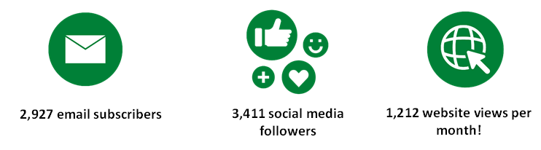
SPONSORSHIP FORM
Please fill out the following form to confirm your chosen sponsorship level. Completed forms can be returned to
Sponsorship Coordinator, at sponsor@savedbynature.org. Please don’t hesitate to contact us at (408) 627-2760 with any questions. Checks can be made out to Saved By Nature and mailed to 2772 Joseph Ave #4 Campbell, CA 95008.

CONTACT INFORMATION:
____________________________________
Company Name (as you wish to be acknowledged)
_____________________________________
Contact Person’s Name

_____________________________________
Company Email Address
_____________________________________
Contact Phone Number

_____________________________________
Address

_____________________________________ City/State/Zip Code
SPONSORSHIP OPPORTUNITIES:
____ $25,000 Environmental & Social Justice Ally
____ $10,000 Environmental Education Hero
____ $5,000 Diversity & Inclusion Champion
____ $1,000 Parks & Open Space Advocate
____ $750 Tule Elk Defender
____ $500 California Badger Protector
____ $250 Steelhead Trout Supporter
____ $150 Burrowing Owl Friend
Once we receive your completed sponsorship form, SBN staff will contact you to discuss event arrangements, sponsorship benefits and recognition. Please send your high-resolution color logos with white and transparent backgrounds (.EPS or vector preferred) to sponsor@savedbynature.org. All materials will be sent for your approval before going to print.
PAYMENT INFORMATION:
____ Please send me an invoice

____ I have enclosed a check made payable to Saved By Nature

____ Please charge my credit card

Card Type: Visa / MC / AmEx / Discover

__________________________________________ ______________ ___________
Card Number Expiration Date Security Code

$_________________________ __________________________________ _________________
Total Sponsorship Commitment Authorized Sponsor Signature Date
THANK YOU.
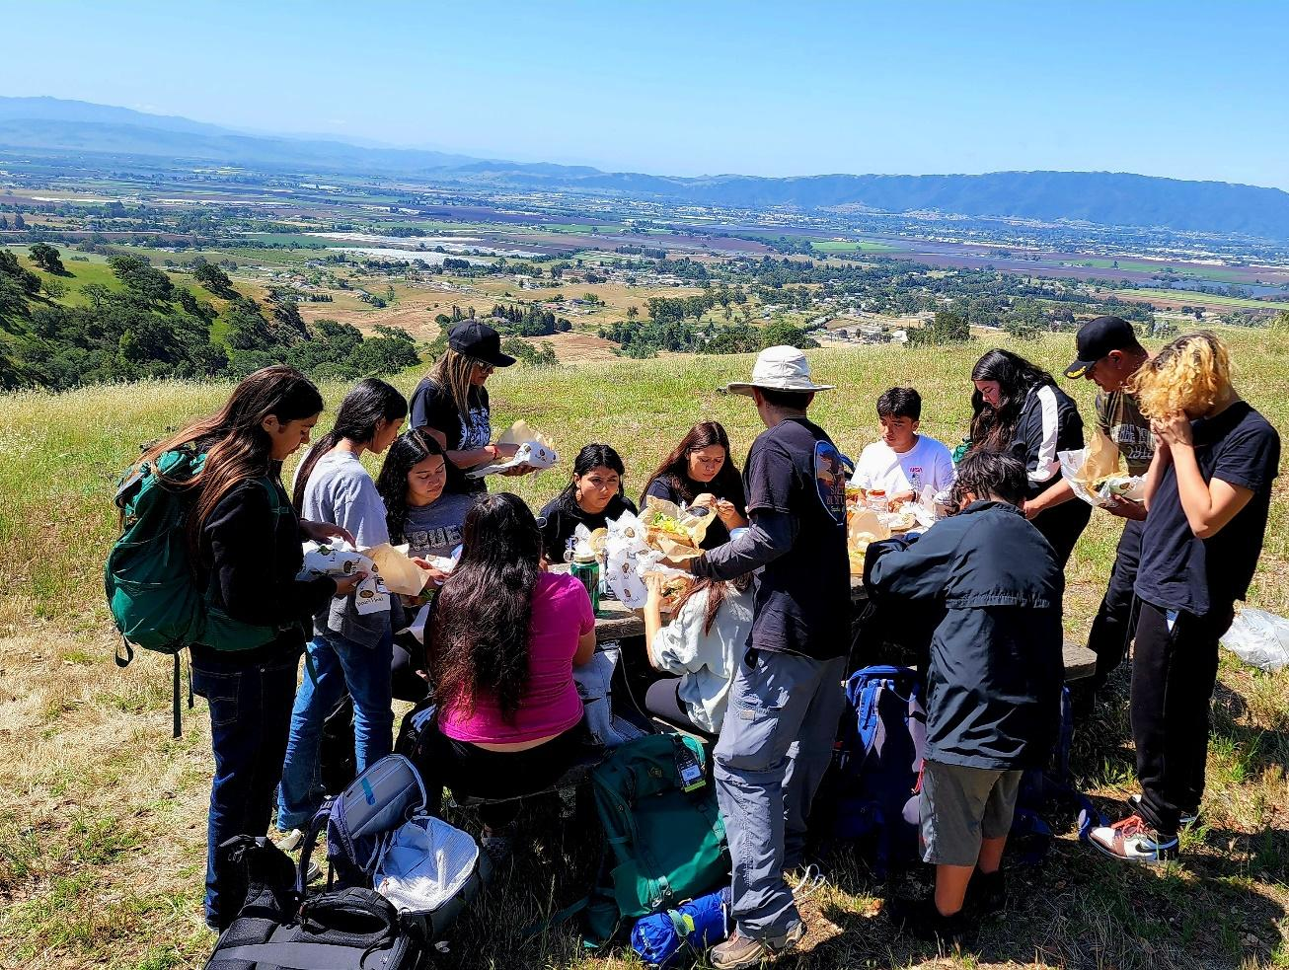
Saved By Nature is committed to fostering a love for nature, wellness, health, and community for beginners & outdoor enthusiasts of all ages in the San Francisco Bay Area and beyond.
Our mission is to expose and connect people of all backgrounds, ethnicities, and abilities to the natural wonders & recreational opportunities of the outdoors. We collaborate with partners to ensure mental, physical, and spiritual healing in nature.
Our vision is to create a world free of barriers and equitable access to nature for everyone. Our efforts additionally inspire advocacy and protection of our earth through safe, fun, and educational experiences.
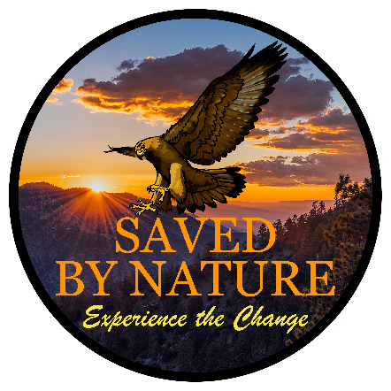
www.savedbynature.org
(408) 627-2760 sponsor@savedbynature.org
2772 Joseph Ave #4
Campbell, CA 95008

